**Focus keyword**: **3 person yoga poses**

**Meta Title:**– **3 person yoga poses** | **Vigoursoul**

**Meta Description**: 3 person yoga positions you can accomplish if you're just getting started with acro yoga or just want to bond with your three best friends.

Feature Image:

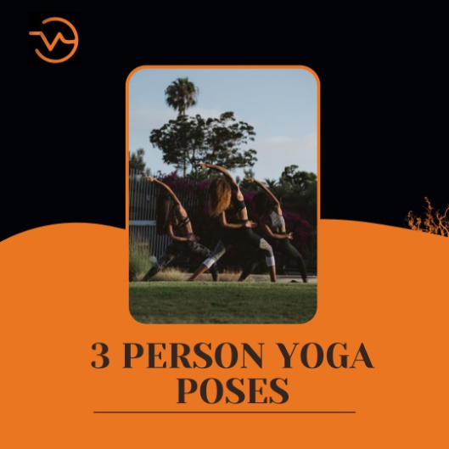

**3 Person Yoga Poses**

The titles of many yoga positions are inspired by animals, natural elements, and names of ancient sages. In order to swiftly communicate the spirit, energy, and shape of each asana, the ancient yogis created symbols that they recognized to have power. A posture's symbolic meaning can be expanded upon by performing it while conscious of it. It may also enhance your **3 person yoga poses** practice by bringing a sense of pleasure, delight, and wonder.

**Origin of Yoga:**

There is no agreement on the history or origins of yoga, except from the fact that it originated in ancient India. There are two main hypotheses that explain how yoga came to be. According to the linear model, yoga was influenced by Buddhism and has Vedic roots (as seen in the Vedic literature). Hindu academics are the main proponents of this theory. The synthesis paradigm states that yoga is a combination of native, non-Vedic practices and Vedic elements. Western academics favor this approach.

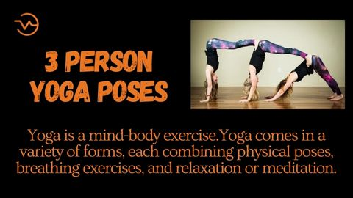

**Who Invented Yoga First?**

Over 5,000 years ago in northern India, yoga's roots can be found. The Rig Veda, a collection of ancient religious books, is where the word "yoga" first appears. Four prehistoric religious writings known as the Vedas were originally authored in Sanskrit.

The Rigveda is the first text to make reference to yoga-like techniques. The Katha Upanishad, which was presumably written between the fifth and third centuries BCE, is the earliest place where the word "yoga" with the same meaning as the current term is recorded. During the fifth and sixth century BCE, the ascetic and ramaa movements in ancient India began to develop yoga as a disciplined study and practice.

The Patanjali Yoga Sutras are the most complete work on yoga and were written in the first centuries of the Common Era. The second part of the first millennium CE saw the emergence of yoga philosophy as one of the six mainstream philosophical systems of Hinduism. The first texts on hatha yoga, which had their roots in tantra, appeared between the ninth and eleventh centuries.

In the West, the word "yoga" is frequently used to refer to a contemporary form of Hatha yoga and a posture-based method of physical fitness, stress relief, and relaxation that is primarily comprised of asanas; this is in contrast to traditional yoga, which emphasizes meditation and the release of worldly attachments.  After Swami Vivekananda's successful application of yoga without asanas in the late 19th and early 20th centuries, it was brought by gurus from India. The Yoga Sutras were brought to the West by Vivekananda, and they gained popularity after hatha yoga's popularity in the 20th century.

**3 Person Yoga Poses Easy:**

If you’re just finding your feet in acro yoga, or simply want to bond with your three best friends, there are many beginner-friendly **3 person yoga poses** you can master.

You can take part in a three person yoga challenge online, join a [group retreat](https://basubu.com/group-yoga-retreats/worldwide) and bond with your besties or simply roll out a yoga mat or two and try out these fun-filled acro yoga poses.

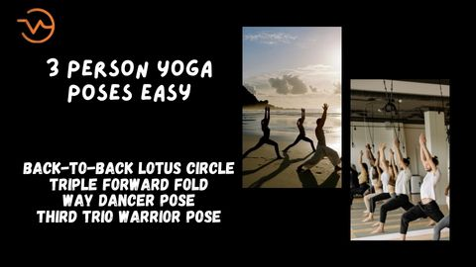

**Back-to-Back Lotus Circle:**

Your body should be back to back and your knees should be touching as you find a comfortable sitting position on the **3 person yoga poses** mat. Bring your hands up over your head while taking a deep breath.

Place one hand on the partner's left leg and the other on the partner's right leg while you exhale. As you assume the lotus position circle, you should feel your back stretch and chest fully expand. You can focus on your breathing or just close your eyes and be in the moment.

### Triple Forward Fold:

On your mat, stand straight up with your backs pressed tightly against one another. Take a deep breath in and raise your arms to the sky while feeling your neck, shoulders, and spine expand.

Release each vertebrae one at a time as you slowly fold forward while exhaling by hinging at the hips. You can clasp hands with your companions or grasp hold of your toes after you've reached your limit. Take a moment to breathe here, and then rise in the same manner, keeping your back straight and core engaged.

### Way Dancer Pose:

Face your companions while standing in a circle. When ready, extend your right leg back and shift your weight to your left leg. In order to elevate your ankle toward the sky, extend your right arm back to meet your leg and hold it firmly.

Lengthen your arms to the centre and grasp hold of your partner's hands as you raise your leg for more support. Feel your body stabilize and stretch as you take a few deep breaths.

**Third Trio Warrior Pose:**

Starting in mountain stance, place **3 person yoga poses** bodies a few metres apart, facing one another. As you inhale, raise your arms in the air. Then, as you exhale, bring your arms, one at a time, to the centre of the circle, and elevate your right leg so that it is parallel to your arms, forming a T with your body.

For further support, you can stack your arms on top of one another or entwine them. Activate your core and match your partners' breathing patterns. Repeat on the opposite side when you get back to the mat.

**3 Person Yoga Poses Medium:**

Unlike traditional **3 person yoga poses** poses, you’ll be expected to perform tricky manoeuvres in mid-air or on the ground with not one but two other people. Practicing yoga with three people is a serious challenge.

**The Plank Press:**

By holding one flyer in each hand during this position, the person at the base is able to support both flyers on his own. He elevates his feet into the air while holding the other flier by the feet. The person at the base has to be an expert balancer. The flyers should also abide by specific methods that would facilitate the execution of the position.

**Downward Dog L-Shape Pose:**

It might be challenging to practice the downward dog with three individuals. Try the flying downward-facing dog or the downward dog pyramid posture if you've practiced triad yoga. However, for acro beginners, the L shape group position is the best. Don't hurry this posture because it's still challenging, and remember to tell your partners if you start to feel wobbly.

The partner who has the stronger core will assume the half-dog posture at the front of the mat for this yoga practice. The subsequent yogi will stand with their feet on either side of the arms of the base. As they progressively pull both feet up to the first yogi's back, they will fold forward, putting their hands on the mat.

**Using Three People and a Flying Plank Press:**

Another blank press variation to round out your stock. This indication ensures that the flyer's balance is not on the straight leg during flight by connecting the opposing leg to the bent leg. ­­­That one can raise the flyer higher than two persons could. It is without a doubt one of the best three-person yoga positions that is accessible.

**Challenge 3 Person Yoga Poses:**

Yoga for three people may greatly improve the harmony and tranquilly between your partners. It is a wonderful opportunity for fun and camaraderie. Working collaboratively and tenaciously to perfect the poses inspires people to recognize their own and their partners' assets and areas for improvement.

**Pyramid Dog Pose:**

In this downward dog pyramid pose, all three yogis assume the position of the downward dog, with one serving as the flyer and the other two serving as the base yogis, supporting the partner above them on their hips.

**A Ballet Pose:**

Flexibility is a must for this pose. Two yogis would spread both of their legs out, the left one bending forward and the right one straightening backward, supporting one another with their foot while the yogi on top would spread her legs out and place them on their shoulders.

**Yoga Position for 3 Persons:**

Yoga positions that involve three people should be practiced. The essential duties in a three person yoga postures practice are as follows.

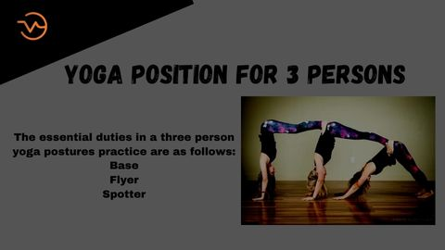

**Base:**

A person who is usually discovered lying on his back just underneath a building or home's foundation. The foundation is trustworthy, so others might be able to rely on it. This is a critical job when it comes to providing others with strength and comfort.

**Flyer:**

At the top of the page, there is a flyer. They'll eventually appear to be flying, which will be thrilling. Depending on the size of the group, there could be one or two flyers in a three-person yoga posture. The ability to balance and coordinate must always be maintained by travellers.

Because it is lightweight and makes it easier to carry out normal tasks, it aids in greater body control and helps you distribute your weight more evenly.

**Spotter:**

Just like the weightlifter, the spotter is in charge of making sure that their own form and that of anyone nearby is upheld during the exercise. You don't need to pay a scout to assist you. If the spotter chooses to do so, they can actively engage in the position. Some 3rd person levels might only have two flyers and a base, while others might have both, depending on the level.

## ****3 person yoga poses-FAQS****

**What yoga pose is the healthiest?**

Savasana is one of the best yoga poses for your general health and well-being, despite its appearance as more of a snooze fest than a yoga pose. You can release tension and possibly lower your heart rate by concentrating on your breath while letting your body relax, which will benefit both your body and mind.

**What, in essence, is yoga?**

Yoga is primarily a spiritual practice that focuses on achieving harmony between the body and mind. It is based on a very delicate science. Healthy living is a science and an art.The Sanskrit root yuj, which means "to connect," "to yoke," or "to unite," is the source of the word "yoga."

**Why is yoga significant in contemporary life?**

Yoga as a practice aids in the control of the mind, body, and soul of the practitioner. It combines mental and physical disciplines to promote relaxation, stress management, and a tranquil body and mind. Additionally, it aids in boosting body tone, muscle strength, and flexibility.

**How is yoga applied in everyday life?**

Yoga aids in maintaining your health. Yoga practice lowers blood pressure, enhances blood flow, builds muscle, and, notably via relaxation, aids in the treatment of insomnia. Yoga philosophy educates you about healthy eating, particularly with regard to what is referred to as the "sattvic" diet in Sanskrit.

**Conclusion:**

The key components for**3 person yoga poses**, and particularly **3 person yoga poses**, are the postures where the body must be flexible and breathe deeply when necessary. The secret to good acro yoga is balance. It involves working in unison with your partners as each body balances itself perfectly and teaches us restraint and resistance.

When practiced mindfully and with specific intentions, yoga has a wealth of benefits and can bring you a lifetime of joy, health, and happiness. This can happen more easily and deeply when you understand not only how to perform a pose, but also the symbolism and meaning behind each one, like unlocking a door inside of yourself.

Yoga is a mind-body exercise. Yoga comes in a variety of forms, each combining physical poses, breathing exercises, and relaxation or meditation. Yoga is a very old practice that might have started in India. In order to enhance both mental and physical wellbeing, it includes breathing exercises, movement, and meditation.